# Build an EMA-based Signal Strategy - Backtest

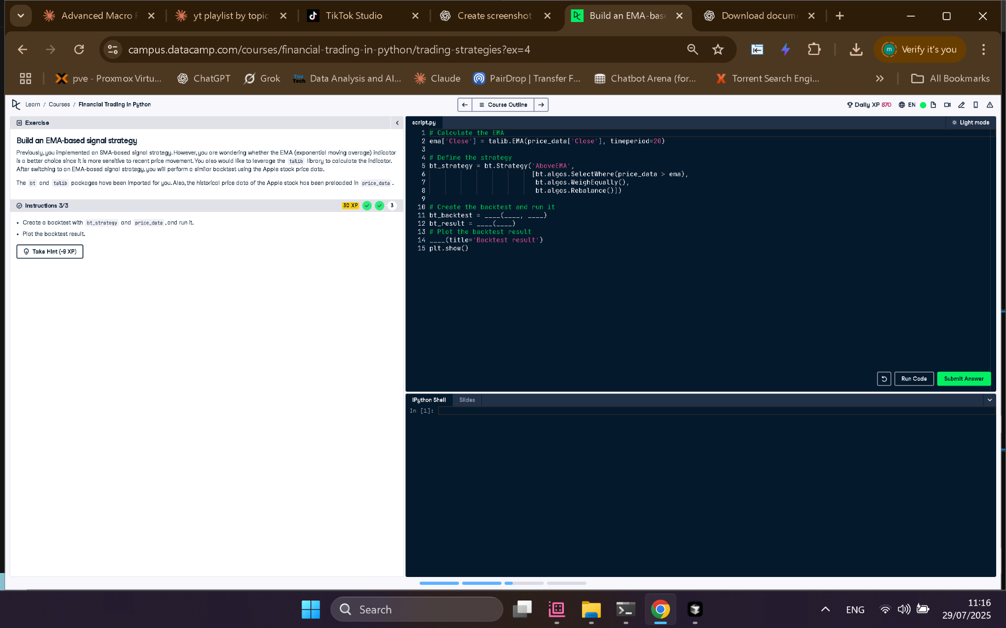

## Python Code

# Calculate the EMA  
ema['Close'] = talib.EMA(price_data['Close'], timeperiod=20)  
  
# Define the strategy  
bt_strategy = bt.Strategy('AboveEMA',  
 [bt.algos.SelectWhere(price_data > ema),  
 bt.algos.WeighEqually(),  
 bt.algos.Rebalance()])  
  
# Create the backtest and run it  
bt_backtest = bt.Backtest(bt_strategy, price_data)  
bt_result = bt.run(bt_backtest)  
  
# Plot the backtest result  
bt_result.plot(title='Backtest result')  
plt.show()

## Explanation (in simple words)

This EMA-based strategy tests if stock prices are above their 20-day Exponential Moving Average. If so, the stock is selected, equally weighted, and rebalanced. The backtest then runs this logic on historical price data to show how well the strategy would have worked.